Project Progress 1

Use Case

Sequence Diagram

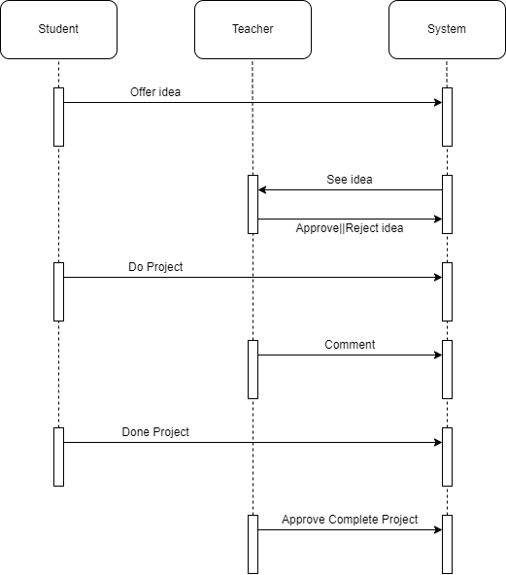

Class Diagram

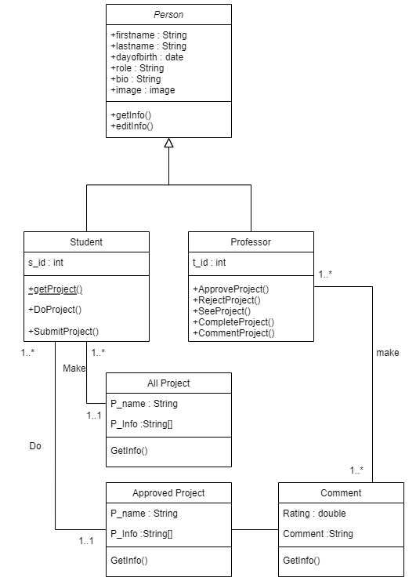

Logical Flow

Core Features

Account

* Log in/out
* Edit Profile

Students

* Add Idea of the Project
* Do Project
* Update Project
* View All Project
* Search Other Project

Teachers

* Approve Project
* Reject Project
* Comment/Rating Project
* Approve Complete Project

Database Design

